Machine Learning Task
Eng:-Ahmed Osman
احمد محمد عبدالمعطى محمد سكشن:-1
بيتر رزق الفونس رزق سكشن:-1
محمد سعيد عبدالله السيد سكشن:- 3
محمد احمد فكري ابراهيم سكشن:- 3
محمود خالد عمر عبدالعزيز سكشن:-4

Abstract
This is a report about a machine learning model for classifying breast cancer cases and predicting whether the cancer is benign or malignant.

Introduction & Dataset Overview
The Task is to predict whether the breast cancer case is benign or malignant, the dataset used is Breast Cancer Wisconsin (Diagnostic) dataset.
The dataset contains 569 cases where 357 of them are benign and the remaining
212 are malignant.
The dataset has the following columns:
- ID number
- Diagnosis (M = malignant, B = benign)
Ten real-valued features are computed for each cell nucleus:
- radius (mean of distances from center to points on the perimeter)
- texture (standard deviation of gray-scale values)
- perimeter
- area
- smoothness (local variation in radius lengths)
- compactness (perimeter^2 / area - 1.0)
- concavity (severity of concave portions of the contour)
- concave points (number of concave portions of the contour)
- symmetry
- fractal dimension ("coastline approximation" - 1)
The mean, standard error and "worst" or largest (mean of the three largest values) of these features were computed for each image, resulting in 30 features. For instance, field 3 is Mean Radius, field 13 is Radius SE, field 23 is Worst Radius.
All feature values are recorded with four significant digits.

- Total code of 3 algorithm:-
# Naive Base Classifier SVC KNN
import pandas as pd # to load data
import seaborn as sns
import matplotlib.pyplot as plt
from sklearn.model_selection import train_test_split
from sklearn.naive_bayes import GaussianNB
from sklearn.metrics import (
accuracy_score,
confusion_matrix,
ConfusionMatrixDisplay,
f1_score,
classification_report
)
from sklearn.impute import SimpleImputer
from sklearn.pipeline import make_pipeline
df = pd.read_csv('./data.csv')
df.head()
df.info()
sns.countplot(data=df,x='diagnosis',hue='radius_mean')
plt.xticks(rotation=45, ha='right')
# Dropping the 'Unnamed: 32' column
# pre_df = df.drop('Unnamed: 32', axis=1)
# Separating features and target variable
# X = df.drop('diagnosis', axis=1) # Assuming you want to drop the 'diagnosis' column
X = df[['radius_mean', 'texture_mean', 'perimeter_mean', 'smoothness_mean', 'compactness_mean','compactness_mean','concavity_mean','concave points_mean','symmetry_mean','fractal_dimension_mean','radius_se','texture_se','perimeter_se','area_se','smoothness_se','compactness_se','concavity_se','concave points_se','symmetry_se','fractal_dimension_se','radius_worst','texture_worst','perimeter_worst','area_worst','smoothness_worst','compactness_worst','concavity_worst','concave points_worst','symmetry_worst','fractal_dimension_worst']]
y = df['diagnosis']
X_train, X_test, y_train, y_test = train_test_split(
X, y, test_size=0.33, random_state=42
)
# Fit the model on the transformed datam
model = GaussianNB()
model = SVC()
model = KNeighborsClassifier()
imputer = SimpleImputer(strategy='mean')
# Create a pipeline with the imputer and Gaussian Naive Bayes classifier
pipeline = make_pipeline(imputer, GaussianNB())
pipeline.fit(X_train, y_train)
model.fit(X_train, y_train)
# Predicting the target variable using the test data
y_pred = model.predict(X_test)
accuracy = accuracy_score(y_pred, y_test)
f1 = f1_score(y_pred, y_test, average='weighted')
print('Accuracy', accuracy)
print("F1 Score", f1)
# Confusion Matrix
cm = confusion_matrix(y_test, y_pred)
cmd = ConfusionMatrixDisplay(cm, display_labels=model.classes_)
cmd.plot()
Classification Report
print(classification_report(y_test, y_pred))
plt.show()
# Assuming you have a new_data variable containing the new data point
new_data = [[14.2, 20.5, 94.7, 0.102, 0.145, 0.186, 0.104, 0.172, 0.175, 0.055, 0.543, 0.476, 3.07, 35.2, 0.008, 0.036, 0.031, 0.011, 0.024, 0.004, 15.3, 24.2, 102.5, 0.163, 0.369, 0.508, 0.242, 0.382, 0.091, 0.03]]
# Use the predict method on your model
# print(X.columns)
output = model.predict(new_data)
# Print the output
print("Predicted Output:", output)

- Total output of 3 algorithm:-
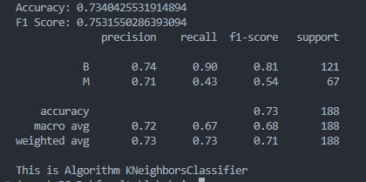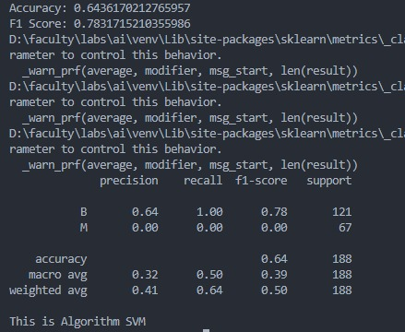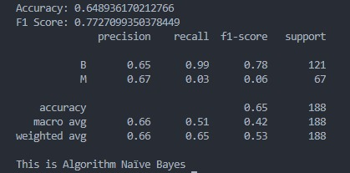
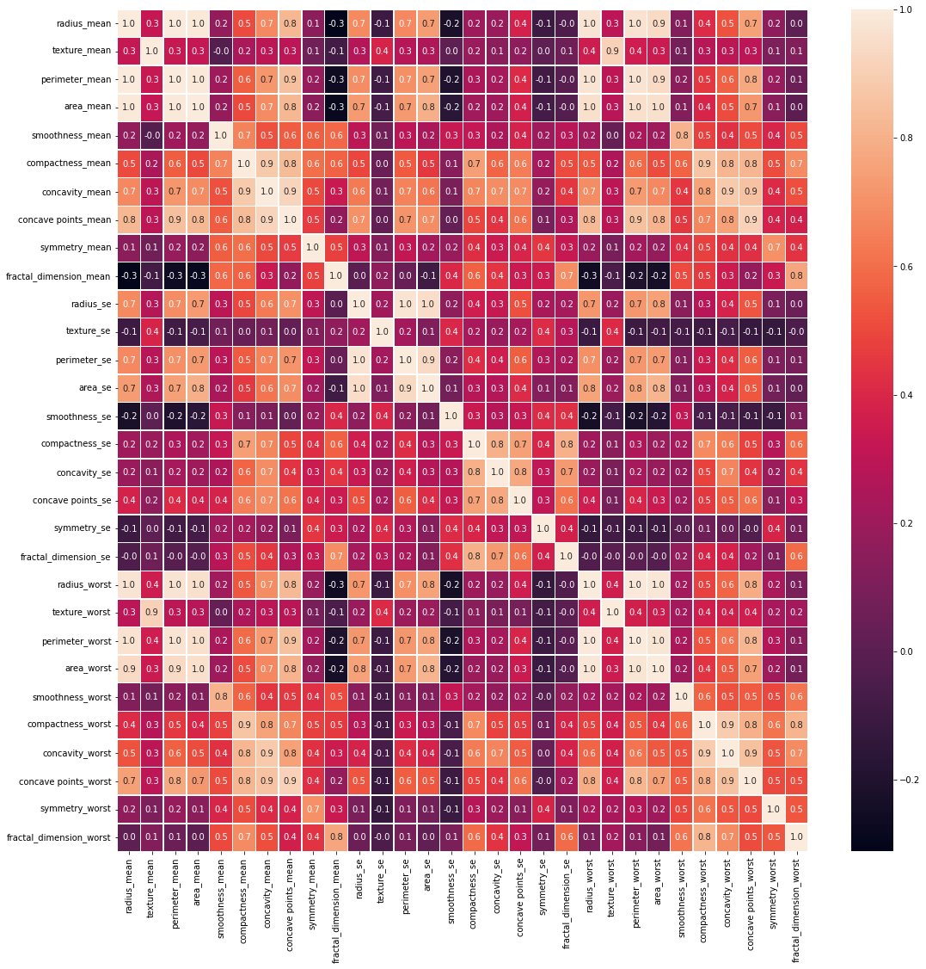
figure(1)
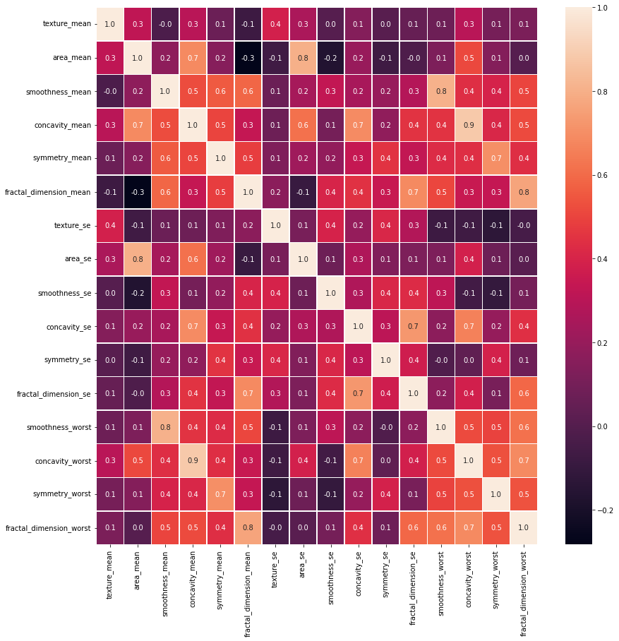
Figure(2)

- Results
We monitored 4 metrics to evaluate our model : Accuracy, Precision,
Recall, and F1 score.
The results obtained are as follows:
Metric | value
Accuracy | 96.83 %
Precision | 96.81 %
Recall | 95.75 %
F1 score | 96.25 %

Attachments
Kaggle notebook that contains the code :
https://www.kaggle.com/code/muhammadabdalsattar/notebook26af019eb6

